**Name: JOMOL R.K**

**Roll No:09**

**Batch:MCA**

**Date:31/03/22**

**NETWORKING & SYSTEM ADMINISTRATION LAB**

**Experiment No.: 5**

**Aim**

**Familiarization of basic LINUXcommands**

**Procedure:**

**1. cut -d ‘ ‘- (f1/f2) <filename.txt>**

**Used to display a particular column on behalf of space delimiter**

**syntax:**

**$ cut -d ‘ ‘ -f1 samples**

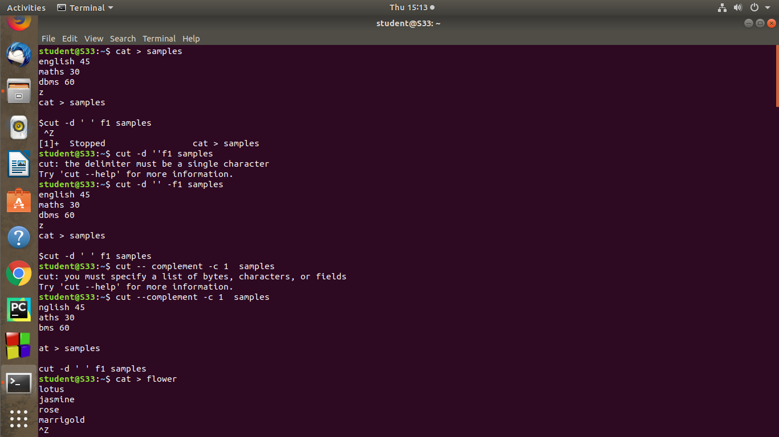**output:**

**2. paste <filename.txt> <filename.txt>**

**It is used to append contents of two files in column order**

**syntax:**

**$paste marvel1.txt marvel2.txt**

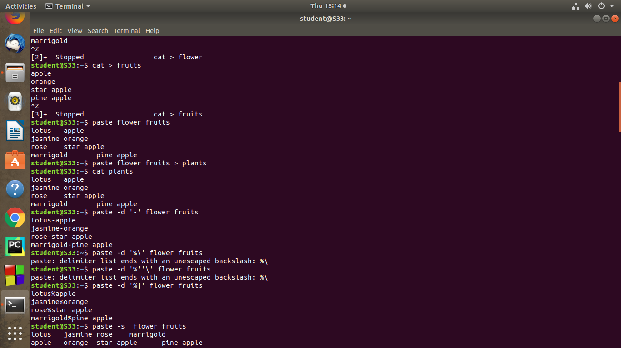**output:**

**3. more <filename.txt>**

**Used to view the text files in the command prompt.displaying one screen at a times in case the file in large**

**syntax:**

**$more file1**

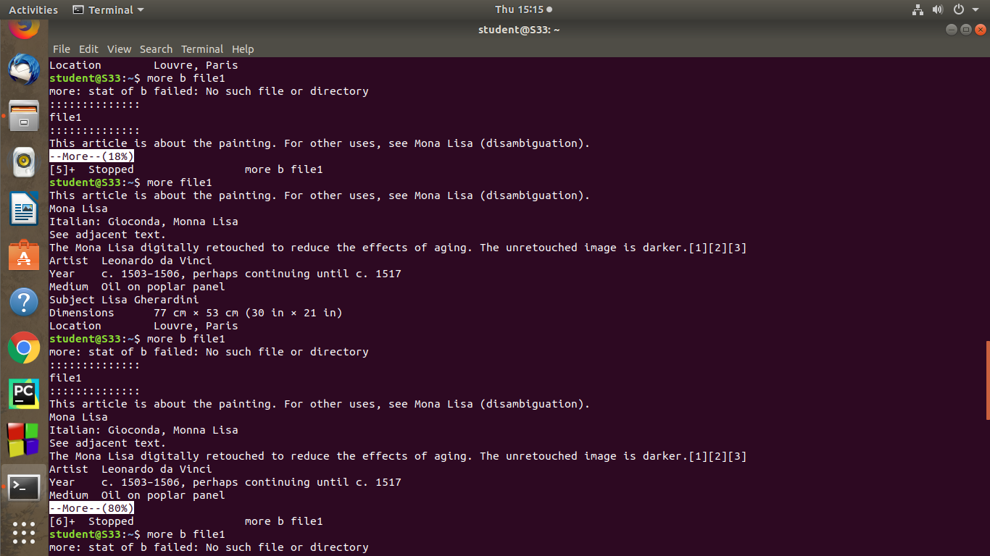**output:**

